Nvidia’s market value topped $5 trillion this week.
The total market value of ALL pharma and biotech companies is $4.6 trillion.
Trending upward
What a week. Avidity Biosciences is being acquired for $12 billion by Novartis, the second-largest biotech M&A deal this year, while Intellia Therapeutics crashed after its CRISPR treatment put a patient into the hospital with a severe drug-induced liver injury.
I count 11 acquisitions, small and large, since September — a remarkable pace of dealmaking that has accelerated the biotech stock rally. Pharma companies are buying commercial and late-stage development biotechs to plug revenue gaps as patents on older drugs expire. It feels like we’re not done yet.
The XBI is up 23% for the year, and now sits at its highest level since January 2022.
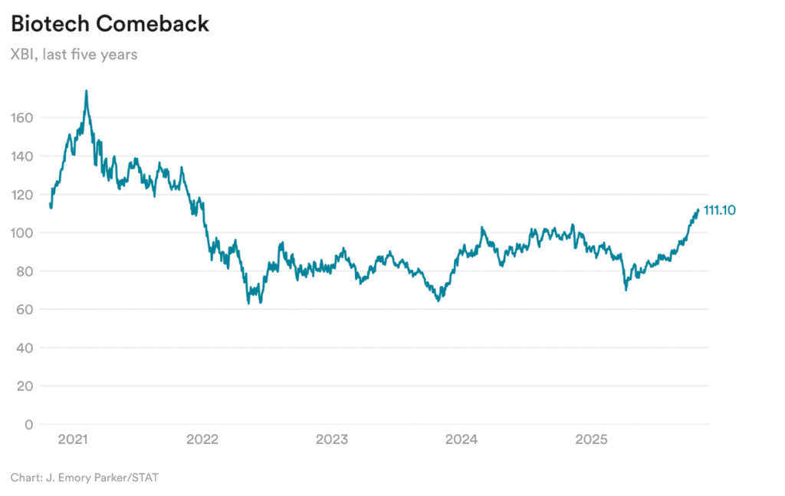
As always, however, the markets viewed through a wider aperture can be sobering.
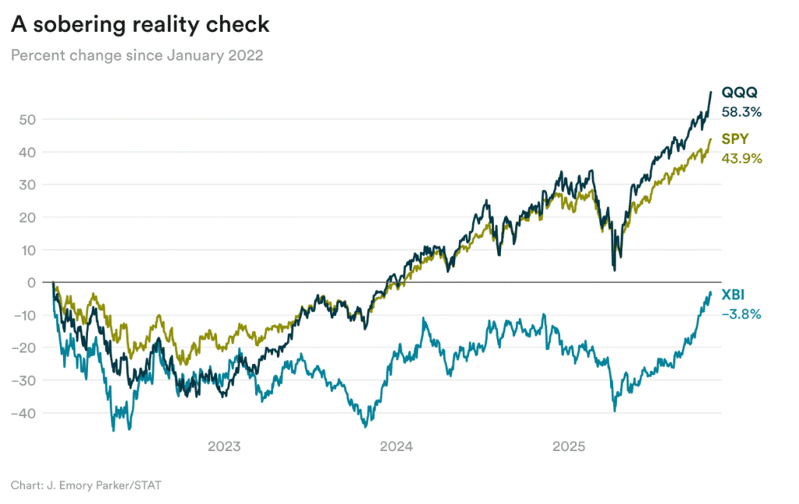
XBI's Dramatic Underperformance: A Perfect Storm in Biotech
The SPDR S&P Biotech ETF (XBI) has delivered a devastating -2.5% total return from January 2022 through October 2025, while the QQQ soared 57.4% and SPY gained 43.4% over the same period. This represents a staggering 59.9 percentage point underperformance versus QQQ and 45.9 percentage points versus SPY — one of the worst sector-specific underperformances in recent market history.
Performance comparison showing XBI's significant underperformance versus QQQ and SPY from January 2022 to October 2025
The Numbers Tell a Brutal Story
XBI's journey has been particularly painful when broken down by year:
2022: XBI fell -28.1%, actually outperforming QQQ's -33.7% decline but underperforming SPY's -19.9% drop
2023: The divergence began in earnest as XBI managed only +9.5% while QQQ exploded +54.8% and SPY gained +24.8%
2024: XBI remained essentially flat at -0.2% while both QQQ (+27.0%) and SPY (+24.0%) continued their strong performance
2025: Some recovery with XBI up +23.0% year-to-date, roughly matching QQQ's +23.9% but still ahead of SPY's +17.2%
The biotech sector's pain reached its nadir on May 11, 2022, when XBI had declined 45.6% from its starting point, representing the deepest trough of the three major ETFs analyzed.​
Root Causes of Biotech's Collapse
Interest Rate Devastation
The biotech sector is exceptionally interest rate sensitive due to its long development timelines and heavy reliance on future cash flows. When the Federal Reserve began aggressively raising rates in 2022 from near-zero to over 5%, biotech companies faced a triple blow:​
- Funding costs skyrocketed, making it exponentially more expensive to finance lengthy clinical trials
- Future cash flows became heavily discounted when applying higher discount rates to drug revenues that might not materialize for 5-10 years
- Risk-free alternatives became attractive, causing investors to flee speculative biotech investments for safer Treasury yields above 4-5%
Research shows that biotech financing was "cut in half" when the Fed started hiking rates in 2022, falling to around 100 deals from previous levels near 200.​
The Venture Capital Drought
Biotech relies heavily on venture capital and private funding to bridge the gap between early research and commercial viability. This ecosystem experienced a catastrophic collapse:
- VC funding plummeted 35-40% from 2021's record $70.9 billion high​
- First-time financings dropped from $2.6 billion to just $900 million in a single quarter during 2025​
- Early-stage VC deals fell 20% year-over-year in 2024, reflecting larger checks going to fewer, safer bets​
The funding winter has been so severe that 39% of biotechs assessed in 2024 were projected to run out of cash within 12 months, forcing widespread layoffs and restructuring across the industry.​
Regulatory and Development Challenges
The pipeline of new drug approvals has faced headwinds that dampened investor enthusiasm:
- FDA approvals declined from 55 new drugs in 2023 to 50 in 2024, with staffing and budgetary cuts potentially impacting review timelines​
- Development timelines extended as companies struggled with reduced funding to advance clinical trials
- Higher clinical trial costs due to inflation and labor shortages made drug development more expensive and risky
Market Structure Vulnerabilities
XBI's equal-weighted structure, while providing broad biotech exposure, made it more vulnerable during downturns. Unlike market-cap weighted indices that benefit from mega-cap stability, XBI's 150+ equally weighted holdings meant that:​
- Small and mid-cap biotech volatility dominated performance with an annualized volatility of 33.3% versus QQQ's 23.9% and SPY's 18.3%
- Binary clinical trial results could swing the entire ETF, as individual companies represent meaningful portions of the fund
- No defensive anchors like the large pharma companies that provide stability in broader healthcare indices
Industry-Specific Headwinds
Patent Cliff Pressures
The pharmaceutical industry faces an unprecedented $350 billion patent cliff from 2025-2030, with the top 20 pharma companies accounting for 80% of this revenue loss. This has created a challenging environment where:​
- Big pharma M&A has been selective rather than broad-based, limiting exit opportunities for biotech companies
- Competition intensified as multiple companies race to develop therapies for the same indications
- Pricing pressure increased from healthcare systems and regulatory bodies concerned about drug costs
Macroeconomic Policy Uncertainty
The Trump administration's policies have created additional uncertainty affecting biotech investment:​
- Potential pharmaceutical tariffs have worried investors about supply chain disruptions
- Research funding cuts threaten the ecosystem supporting early-stage biotech innovation
- Leadership changes at public health agencies have introduced regulatory uncertainty
The Recovery Question
Recent data suggests the worst may be behind XBI, with some encouraging signs:
- Interest rate cuts beginning in 2024 have improved the funding environment for long-duration assets like biotech​
- M&A activity surged in 2024, with biopharma deals more than doubling in Q1 compared to the prior year​
- XBI bounced 50% from its November 2023 lows, breaking above $100 for the first time in two years​
However, the sector remains fragile with "cautious optimism" being the prevailing sentiment among industry experts. The combination of higher volatility, extended development timelines, and continued macroeconomic uncertainty means biotech investments require strategic patience and strong risk tolerance.​
Conclusion
XBI's massive underperformance versus QQQ and SPY reflects a perfect storm of factors specific to the biotech sector: extreme interest rate sensitivity, venture funding collapse, regulatory headwinds, and structural vulnerabilities in an equal-weighted portfolio of speculative companies. While 2025 has shown some recovery, the biotech sector's fundamental challenges — long development timelines, binary outcomes, and heavy capital requirements — make it particularly vulnerable to macroeconomic cycles and investor sentiment shifts.
For investors in biotech, this period serves as a stark reminder that innovation sectors can dramatically underperform during periods of monetary tightening and risk-off sentiment, regardless of the underlying scientific merit of the companies involved.

